CURRENT CONTROL SYSTEM

The way in which we obtain the generator field voltage.

REVIEW OF ARMATURE CURRENT GENERATION

You have learnt of the basics of the Ward-Leonard closed-loop system. As we stated in module, nearly all Ward Leonard closed-loop systems in consist of the electronic controllers and static power converters called Thyristor converters.

Fig 1.1 shows the basic system of generation and control of armature current.
If you look at winder drawings, you will see that what you have got on your winder is much more complicated, particularly the thyristor converter section.
When we study this section, we will study it from a FUNCTIONAL point of view. As we have said before, we will study WHAT the system does, and how it is done.
The Ward-Leonard current control system is based on the Siemens Simadyn/Simoreg D.C. drive system - so we must firsts look at the history of the system.

THE HISTORY OF THE GENCOR ELECTRONIC-TYPE WARD-LEONARD CLOSED- LOOP CONTROL SYSTEM (EMPLOYING ELECTRONIC-TYPE CLOSED LOOP CONTROLLER AND THYRISTOR CONVERTER).

The first electronic, thyristor-converter-type Ward - Leonard system in used the Siemens/Simadyn system (for speed control of D.C. motors), and adapted it to suit the Ward - Leonard drive. On the older winders you will see that even the speed control section as described in the previous module, was done using the Siemens system.
On later winders, the speed control section was made separately, and the armature current controller, filed current controller and thyristor converter were taken from the Siemens system.
On the latest generations of Ward-Leonard winders, the Simadyn/Simoreg system has been replaced with a locally manufactured one, but based on the Siemens system.
In this module then, we will study the Siemens system of armature current generation and control, but first you must learn the basic of thyristors and thyristor converters.

THE THYRISTOR CONVERTER

You have learnt that the thyristor converters we use on the mine winders convert and A.C. 3-phase supply into a variable voltage D.C. supply which is used to supply field current or excitation to the generator of the M.G. set.
You also should know that a thyristor converter on your underground battery locos converts a constant D.C. supply to a variable voltage D.C. supply to drive the battery locos.

What do the thyristors actually do?

To understand this, you must learn a little about thyristors.

The Thyristor Bridge

You must think of a thyristor as a diode that you can control. The symbol for a thyristor even looks like that of a diode.

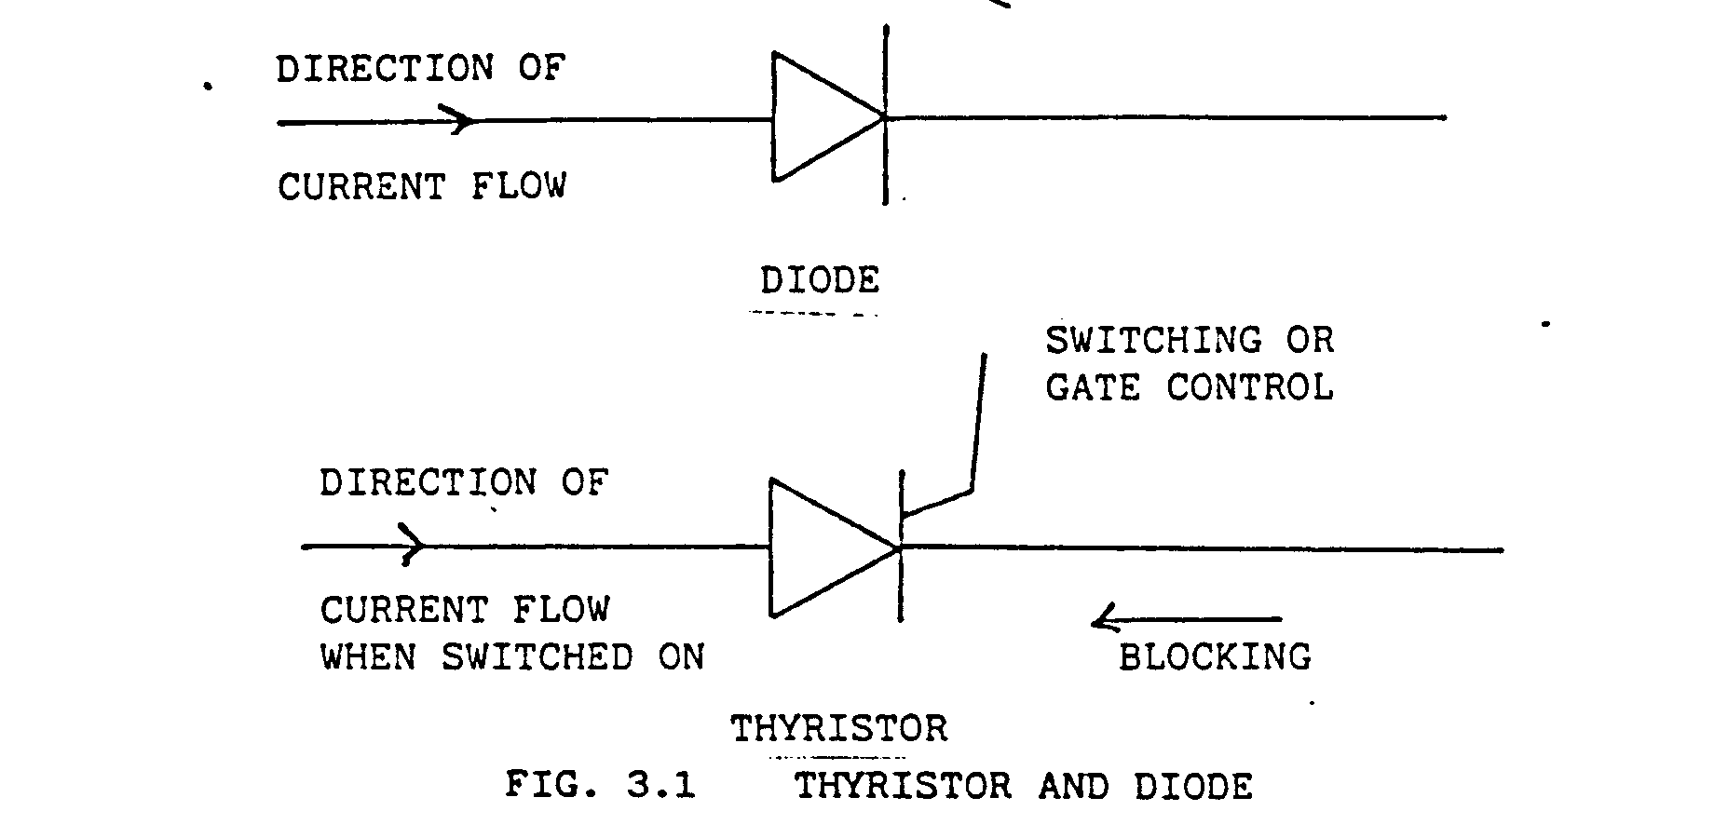A Thyristor blocks current in the reverse direction just like a diode. A diode does not try to block current in the forward direction. A thyristor will block current in the forward direction until it is switched on by a voltage on the gate (or switching control) lead.
You know how a diode rectifier works. Fig 3.2 shows a 3-Phase full-wave rectifier bridge.
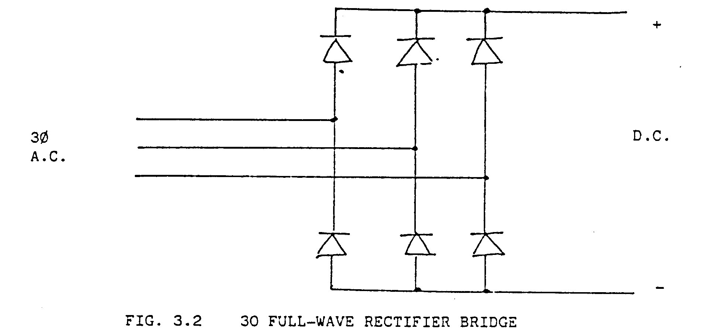
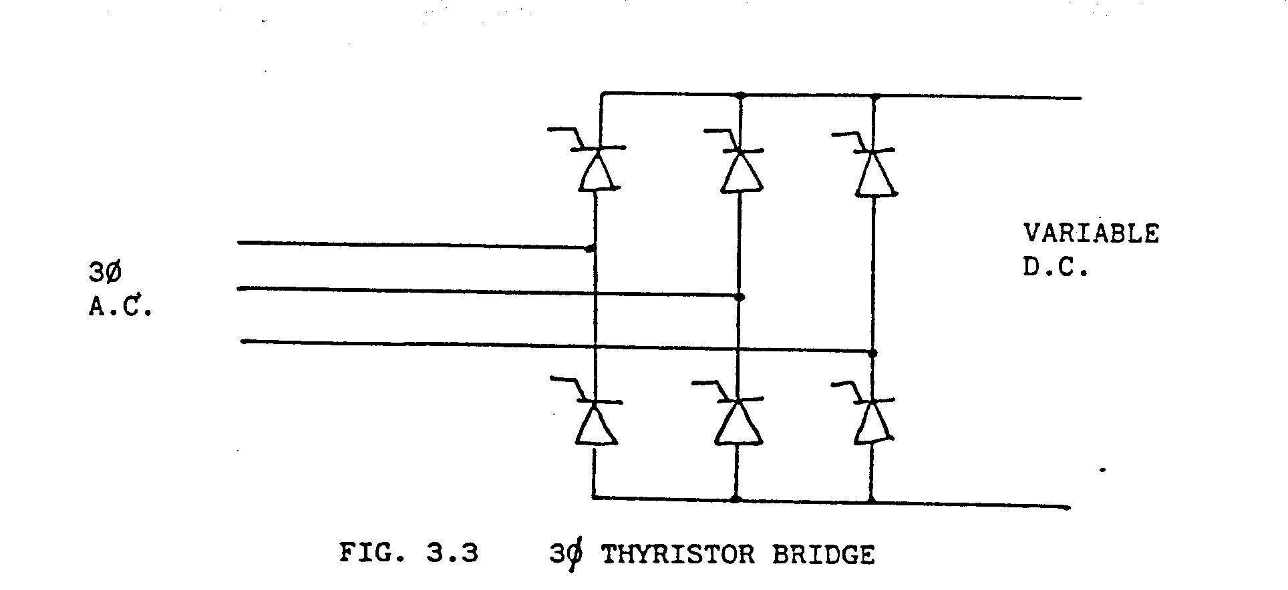In a rectifier bridge the input is constant A.C. Voltage and the output is a constant hyristor bridge. (By fully controlled we mean that all the elements are thyristors).
With a thyristor bridge, the input is a constant A.C. voltage and the output is a variable D.C. Voltage. The D.C. voltage is varied by changing the ‘time” at which the thyristors are turned on by the gate or control. This time is normally called “firing angle” or “firing delay” and is called alpha.
Alpha is measured in degrees and we will discuss shortly what a change in alpha does to the D.C. output. There is a gate pulse to each thyristor in every cycle of the A.C. voltage. As you know, with an A.C. Frequency of 50 HZ, one cycle lasts 1/50th of a second or 20 milliseconds.
Because of the high frequency of the gate pulses, you cannot measure them with a multi-meter, but need to look at the waveforms on an oscilloscope.

Current control and Generation

As we explained the electronic-type Ward - Leonard closed -loop control system, there are three negative-feedback control loops or control sections, each employing a closed-loop PI controller (Proportional and Integral controller), namely:

1. The speed control negative-feedback control loop (or speed control section).

2. The armature current negative -feedback control loop (or armature current control section).

3. The generator field current negative - feedback control loop (or generator field current control section).

Fig. 4.1 shows a schematic of the complete armature and field current control of a Ward - Leonard hoist. We will look at each section in detail at a later stage. First study Fig. 4.1
You must refer back to this figure in each of the following sections.

There are two trigger sets. The master trigger set fires the forward bridges and the slave trigger set fires the reverse bridge.
The outputs from the trigger sets are firing pulses to the thyristor.
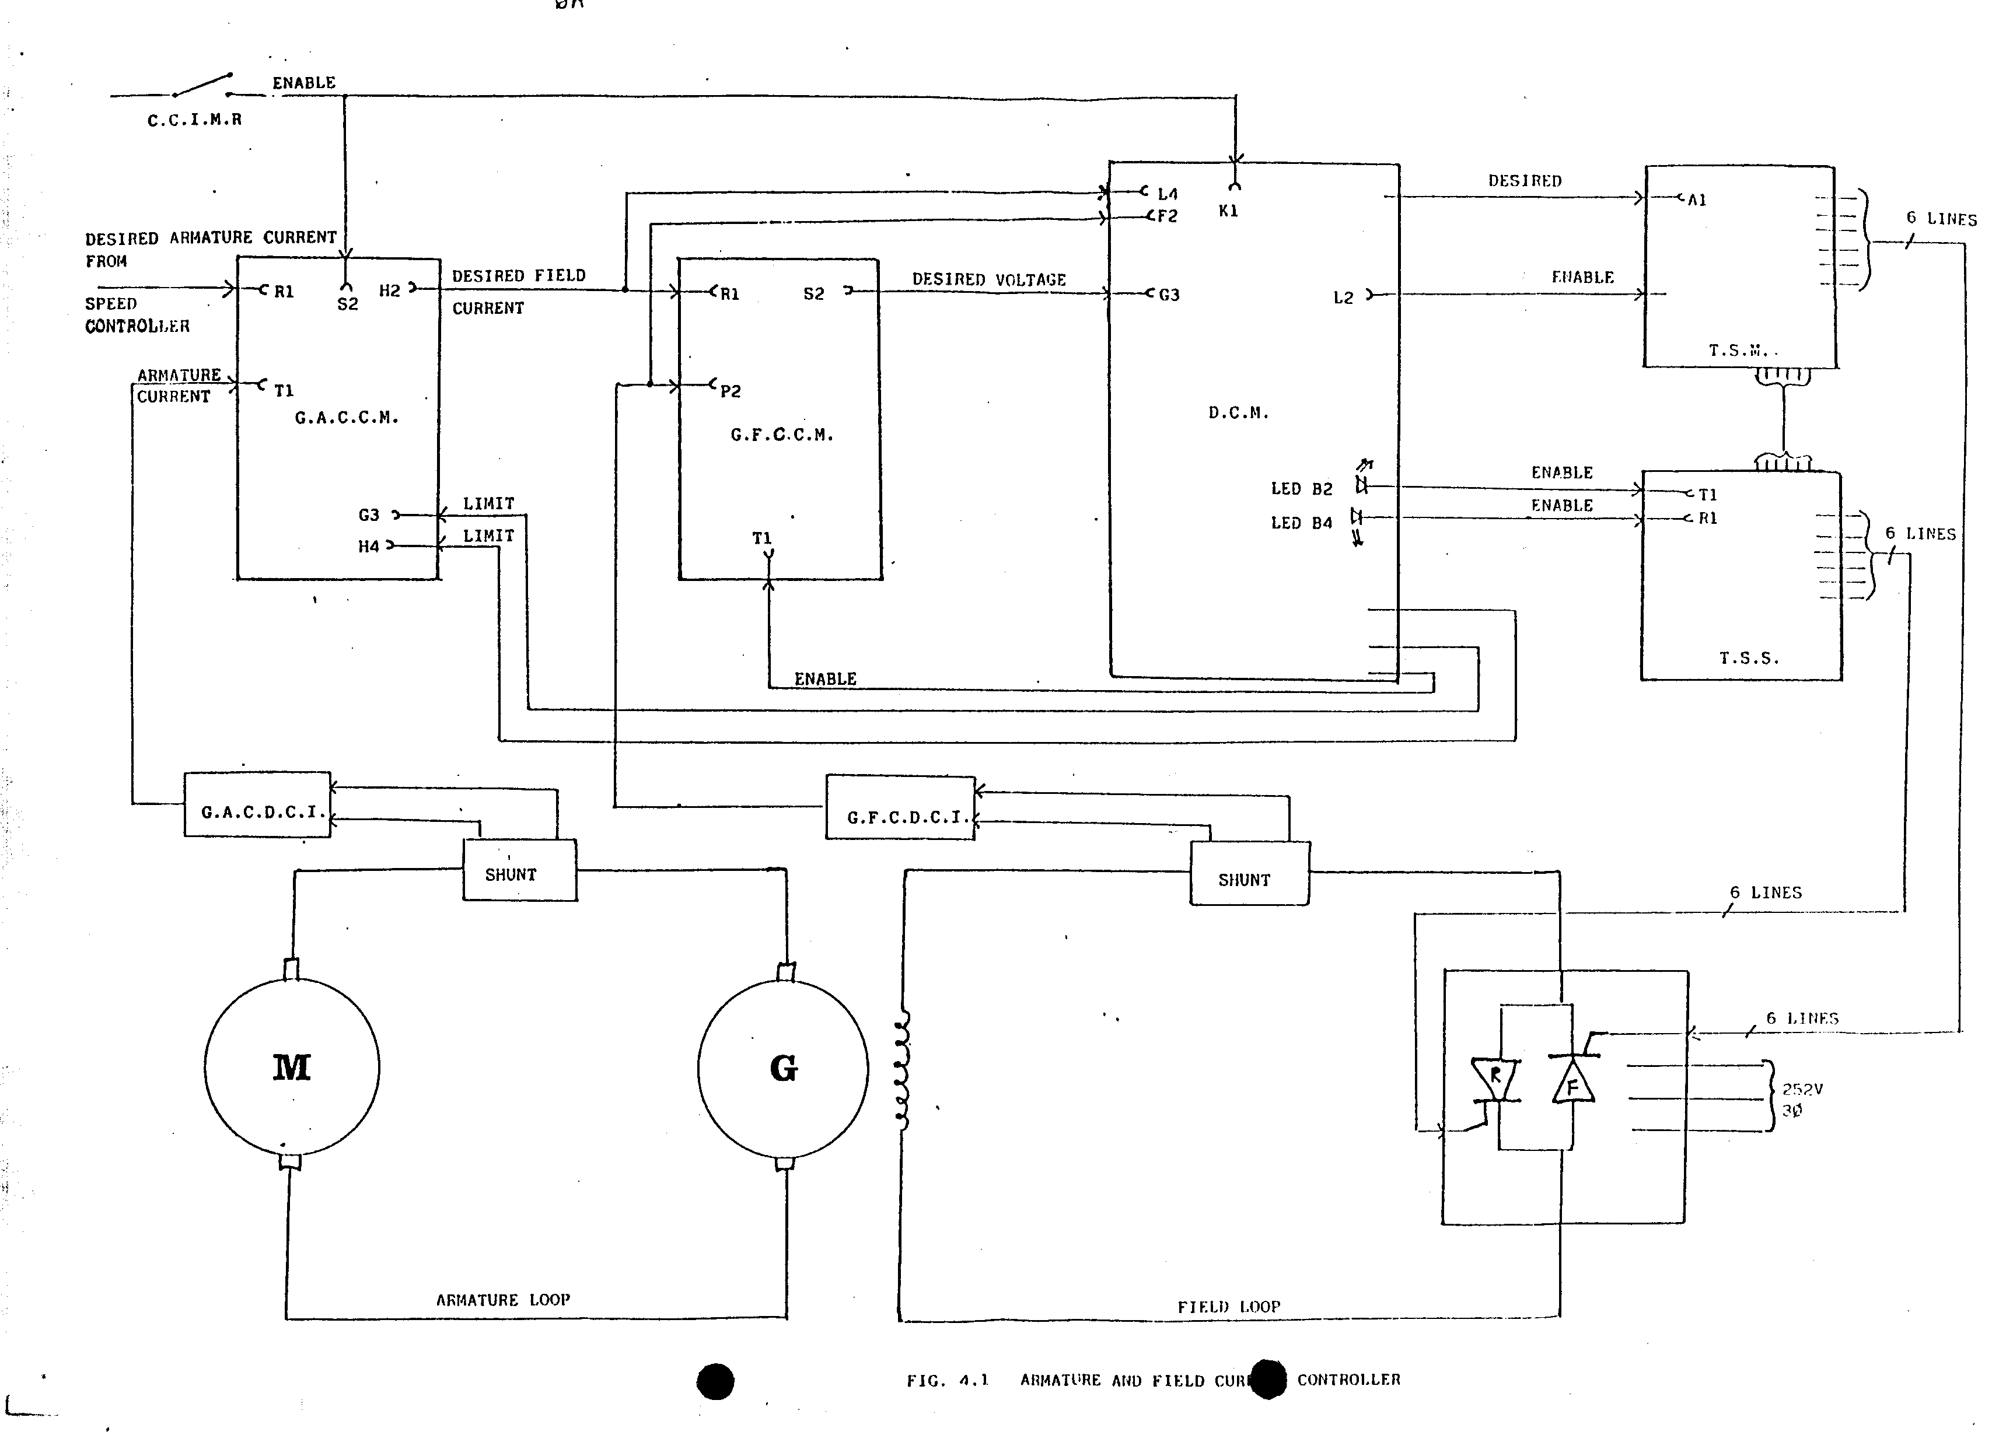
We will now study the system in detail.

Generator Armature Current Controller (G.A.C.C.M.)

The armature current controller is a P.I. controller. The desired value of armature current from the speed controller can be measured at TP RI on G.A.C.C.M. This value is between 0 V and + 10 V for forward armature current and between 0 V and - 10 V for reverse armature current.

The actual value of armature current from the main loop shunt is fed into the Generator armature current transducer G.A.C.D.C.I. and the value can be measured at TP TI on G.A.C.C.M. This gives 0 V to -10 V for forward armature current and between 0 V to + 10 V for reverse armature current.

The output of the armature current controller is the M.G. set generator field signal. This is the desired value of field current.

0 V gives 0 desired field.
+ 10 V gives full desired field current (forward).
- 10 V gives full desired field current (reverse).

These voltage can be measured at TP H2 on G.A.C.C.M. Test these voltages with a multimeter.

There are some inputs to G.A.C.C.M. which will shut the controller down.
These are:

- Enable lines (TP S2). +24 V at this test point means that the controller is enable (can operate). This enable
is controlled by the current Control Inhibit Module Relay (CCIMR). Check in the re y logic diagram when this relay is energised.
b) Two inputs (TP G3 and H4) limit the output of the G.A.C.C.M. the Digital Command Module Controls these input ( more of this later). + 10 V at TP G3 and - 10 V at TP H4 means that the controller outputs is not limited.

c) The Armature current limit ( Maximum armature current) can be set on Potentiometers B2 and B4.

Generator Field Current Controller (G.F.C.C.M.)

The generator filed current controller is a P controller (i.e. Proportional only) which gets the desired value of field current from the armature current controller. This can be measured at TP R1.

+ 10 V gives full forward field current.
0V gives zero field current.
- 10 V gives full reverse filed current.
The actual value of field current from the field shunt is obtained from the Generator Field Current Transducer (GFCDCI). This is input at TP P2 on G.F.C.C.M.

- 10 V means maximum forward field current.
0V means zero field current.
+ 10 V means maximum reverse field current.

The output of the field current controller is the desired voltage needed on the field to give the field current. This is therefore a voltage needed from the field thyristor converter. This output can be measured at TP S2 of G.F.C.C.M.

+ 10 V for full forward filed voltage.
0 V for zero field voltage.
- 10 V for full reverse filed voltage.

An enable line from the Digital Command Module allows G.F.C.C.M. to operate. This enable signal measured at TP T1 on G.F.C.C.M. must be = 10 V when the controller is operating. We will discuss the switching of this enable line in the next chapter.

Test on G.F.C.C.M. for the voltages at the test points we have mentioned. Make notes in this module of the voltage you have found.

